Notarize

Purpose: To demonstrate how to set up and use the Notarize integration, which allows a user to create a transaction in Notarize from within ResWare, add documents to the transaction, and schedule a signing. Post-signing, the executed documents will be returned directly to the file in ResWare, and a note will be added to the file to indicate that all the executed documents have been added.

Begin here: Contact Notarize for further information or to register for services at https://www.notarize.com/contact-sales-title-network. Inform the sales representative that the account will be for a ResWare integration. Account information will be provided, including the account username and a password to use in the ResWare to ResWare mappings step.

Next: Follow the setup steps in this job aid. The account information provided by Notarize is needed to complete these steps.
Next: Contact the Adeptive customer success team at support@adeptive.com to assist with adding the necessary bindings and endpoints for successful transmission between ResWare and Notarize. Provide the SystemID for the partner created below.
Then: Test.
Table of Contents
Version history 3
ResWare office ID and website URL 4
Enable office option 4
Create a Notarize partner 5
Create a partner employee 6
Password validation 7
Signing Types 8
Document set up 9
Incoming document type 9
Outgoing document types 11
Configuration in Notarize 12
Organization profile 12
Contact mappings 12
Documents 13
Team 14
Underwriters 15
Users 16
ResWare to ResWare partner mappings 17
Order placement 17
Note/Document 18
Signings 19
Enable the XML tab on products 20
Examples on a file 21
eClosing eligibility 21
Signings 22
Sending an order 23
Send signing manually 24
Automate using actions 25
Sending documents 25
Send the order 26
Send the documents 28
Send the signing 30
Workflow process 32
Receive notarized documents 34
Signing updates 35
Signing cancellation 37
Text placeholders 39
Types 39
Req 39
Users 39
Sizing 40
Defining a variable 40
Example 41
ResWare merge fields for text placeholders 42
Entity signatories 43
Custom fields 43
Template 44
Example on a file 46
Troubleshooting 48

Version history
Version | Date | Description
8.26.43 |  | Initial integration built
9.1 | May 2019 | Notarize V2 has been available since ResWare v9.1: Use ResWare to ResWare to send orders as well as distinguish signing types ordered and documents types sent to Notarize.
 | 06/13/2019 | As instructed by Notarize, the following website roles are not needed for the integration: Add Documents, Add Notes, Edit Buyer/Seller, View Buyers, View Sellers, Web Services Get Documents, and Web Services: Get Partners.
 | 07/25/2019 | Removed note regarding restriction on signing types (Notarize’s transaction types) and added additional underwriters (Alamo, Chicago, Commonwealth, National Investors, North American Title).
 | 09/26/2019 | As instructed by Notarize: All outgoing documents are to be in PDF format. Added outgoing document types section.
9.7 | 11/13/2019 | As instructed by Notarize: RW2RW document mapping – Remote IDs are now using the ResWare DocumentTypeIDs and mapping these in the Notarize web portal. Updated Incoming DocumentType section, updated Notarize configuration section to show the new mapping of document types, and added the eClosing eligibility sub section.
9.7 | 01/31/2020 | As instructed by Notarize: Add Signing type mappings 8,10,11,12,13. Add UW #17041. Add Signings/Special Instructions info. Update workflow process order. Add signing updates and cancellation info.
9.7 | 03/31/2020 | As instructed by Notarize: Add troubleshooting resolution for RW2RW Order Placement URL and add white text placeholders using the preferred syntax for tagging documents for signings. Added signing types set up section.
9.7 | 05/25/2020 | Added ResWare merge fields. Added link to the customer portal. Added entity signatory custom fields. As instructed by Notarize: Update contact information. Add contact mapping. Update URLs for RW2RW mapping. Add new UWs on NTZ portal to map in RW2RW.

ResWare office ID and website URL

Admin/General Setup/Offices
Note the office ID for each office that will use this integration, along with the URL that is used to access the company’s ResWare website. These will be needed for a step later in this job aid. If the ResWare website URL field is blank, then contact support@adeptive.com to request this information.
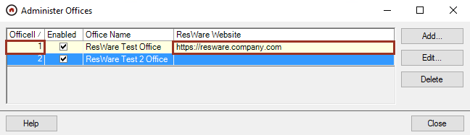

Enable office option

Admin/General Setup/Offices

Highlight the office using this integration and click Edit.

Click on the Web Services tab or use the Search function to locate office option.

Click to enable the Enable ResWare to ResWare Order Submission office option.
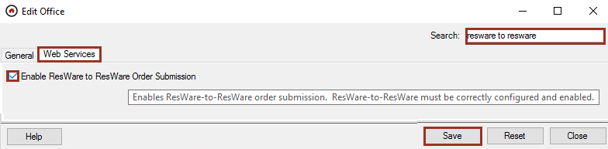

Create a Notarize partner

Admin/Partners

Click New.

Enter the Company Name as Notarize.

Enter the partner’s information and set the Partner Type as Notary.

Click XML Config and check both Enable XML Transmission of Notes and Documents and Don’t Also Send Notes and Documents via Email.

Click Edit Cities.

Select all states/cities where services are provided.

Click Save, Save.

Note: This partner will need to be added to each file using this integration service. It can be auto added by another partner, by the action list, or manually added by a user.

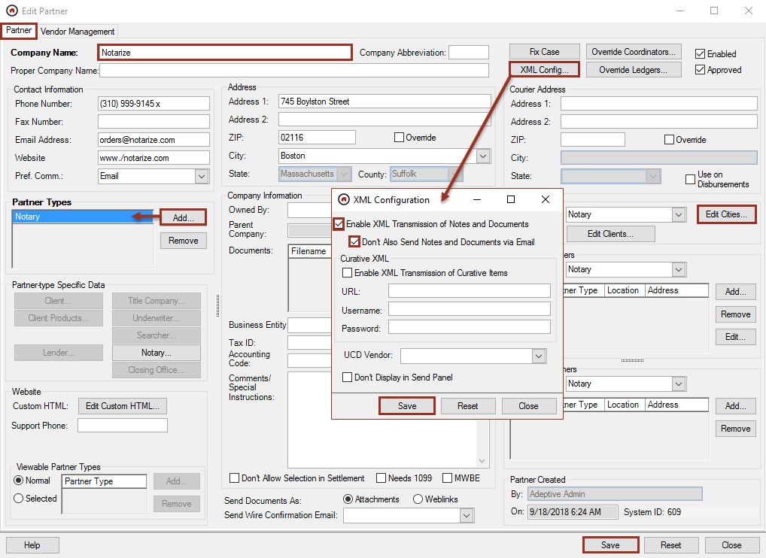

Create a partner employee

Admin/Partners
- Highlight the partner created above and click New in the partner employee area.
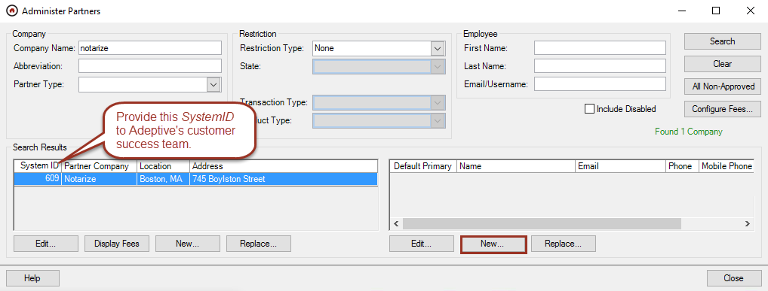
- Enter the First Name as Notarize Integration Services.
- Enter the Email Address as orders@notarize.com.
- Check Primary Contact, which will set this employee to the primary contact by default when the partner is added to the file.
- Check Enabled in the Website Access area, which allows the web services to be utilized.
- Check Override Username and enter the Username as Notarize.
- Click Generate to populate a Password. This will ensure company-specific password requirements are met. Write down this password to use in the validation step.
- In the Website Roles area, enable the following roles:

Edit Buyer/Seller (if version prior to 9.7)
  - View Buyer (if version 9.7 or greater)
  - View Seller (if version 9.7 or greater)
  - Web Services: Add Documents
  - Web Services: Add Notes
  - Web Services: Get Custom Fields
  - Web Services: Get Notes
  - Web Services: Search Files
- In the Office Access area, check Access for the offices where services will be provided. Optionally, check Default if an office will be the primary office.
- Click Save.
Note: The username and password for the employee will be needed for a step later in this job aid.
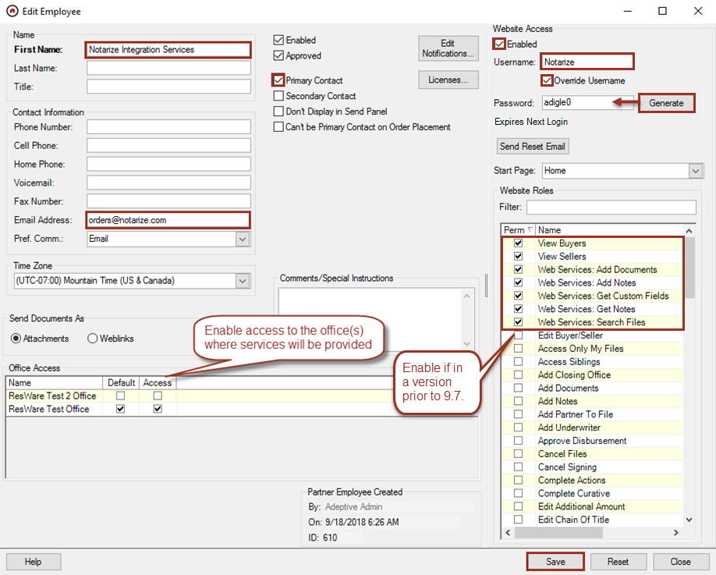

Password validation

Website
After a password is set or reset for a partner employee, the employee is required to enter a new password the next time they access the website. To ensure that this integration is set up correctly, log into the company’s ResWare website with the username and password created in the prior step and create a new password. Provide this new password to Notarize.
Note: It may be beneficial to set the expiration date of this password on the partner employee setup out for an extended period. Check with company-specific password security protocols to verify this will be acceptable or have a reminder in place to update this password as needed to ensure this integration’s service will not be interrupted.
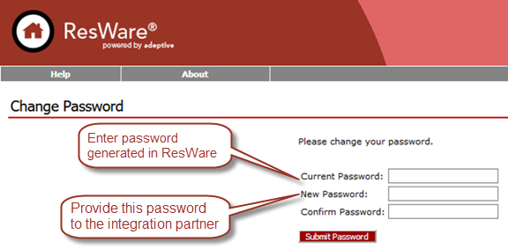
Note: The Username and Password will be needed for a step later in this job aid to ensure the documents are returned on the file’s Documents panel.

Signing types

Admin/General Setup/Signing Types

The following chart shows the signing types this integration will need to be created in ResWare to allow Notarize to access along with their remote IDs. These remote IDs will be needed for a later step in this job aid.
Type | RemoteID
Hybrid purchase | 11
Hybrid purchase, buyer cash | 12
Hybrid refinance | 8
Hybrid trailing docs | 10
Purchase-buyer cash | 4
Purchase-buyer loan | 5
Purchase-seller | 3
Refinance | 1
Trailing docs | 2

Click Add.

Enter Name such as Trailing docs.

Click Save and repeat until all types are entered from the chart above.

Click Save.
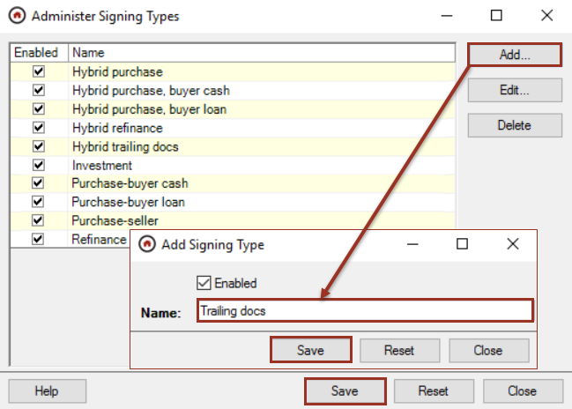

Document set up

Incoming document type

Admin/Documents and Templates/Document Types
A unique document type should be used when a set of merged notarized documents are received so this package can be more easily identified. This document type is also used for testing. The following chart shows the document types this integration will need to exist or be created in ResWare to allow Notarize to return them to a file. Make note of the DocumentTypeIDs to map in the configuration step.
DocumentTypeID | DocumentType
 | Notarize Executed Documents
 | Buyer’s Package Executed Documents
 | Seller’s Package Executed Documents
 | Invoice
 | Signer Photo IDs

- Click Add.
- Enter the Document Type such as Notarize Executed Documents.
- Verify that the Default to Internal Only is unchecked.
- In the Website area, check Allow upload for Partner Types.
  - Either check All for all partner types

OR
  - Check Select and click on Edit to choose which partner types may upload the document.
    - Click Add.
    - Highlight the partner types, then click Add.
- Click Save.
- Repeat to create the remaining document types needed.
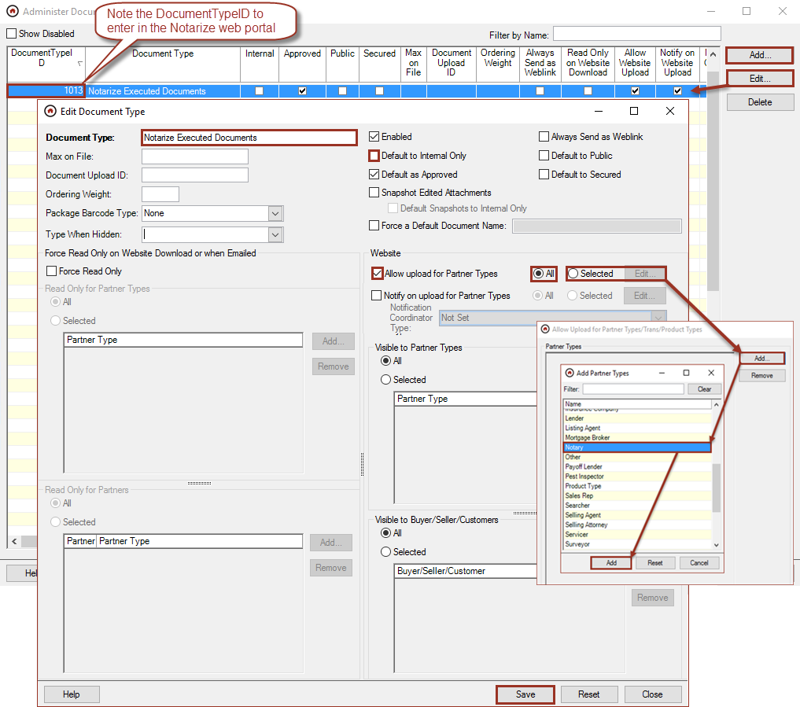

Outgoing document types

Admin/Documents and Templates/Document Types
All documents sent to Notarize must be in a PDF format. Any other file type will trigger an error message from Notarize requesting a PDF version of the document. Therefore, all documents that may be sent to Notarize will need to be set as Force Read Only for this partner in addition to being mapped in the ResWare mapping step below.
- Verify Default to Internal Only is unchecked.
- Edit a document type and, in the Force Read Only on Website Download or when Emailed area, click Force Read Only, then
  - In the Read Only for Partners area, click Selected and Add to search and add the Notarize partner.
- Click Save.
- Repeat for each document that will be sent to Notarize through this integration (see step below).
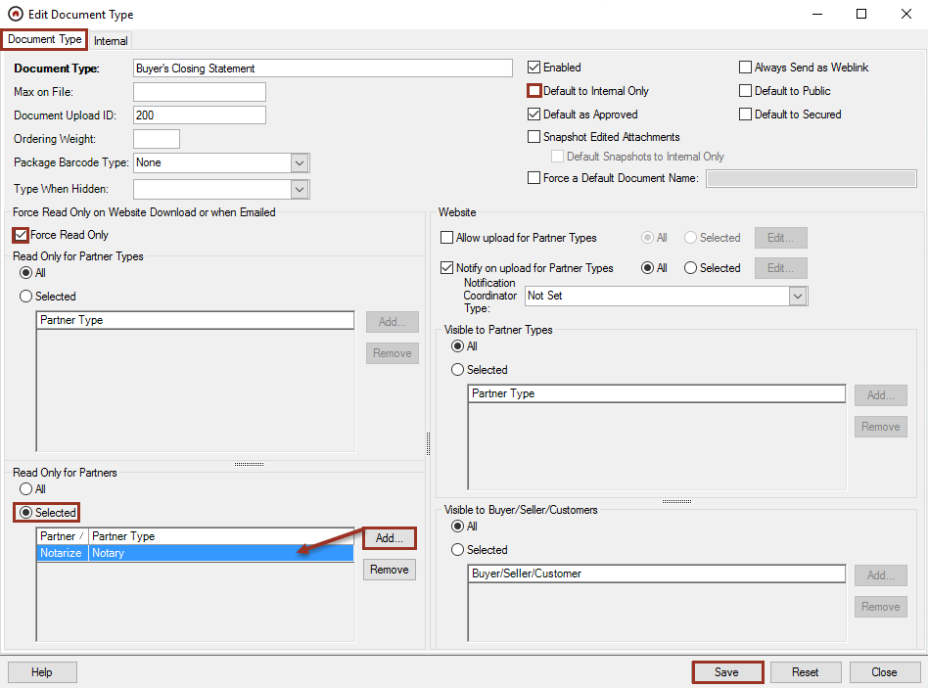

Configuration in Notarize

Organization profile

Resources/Integrations/Organization Profile

With the OfficeID, website URL, DocumentTypeIDs, and partner employee username and password, log into the Notarize title account at title.notarize.com and complete the setup information.

Resources/Integrations/Organization Profile
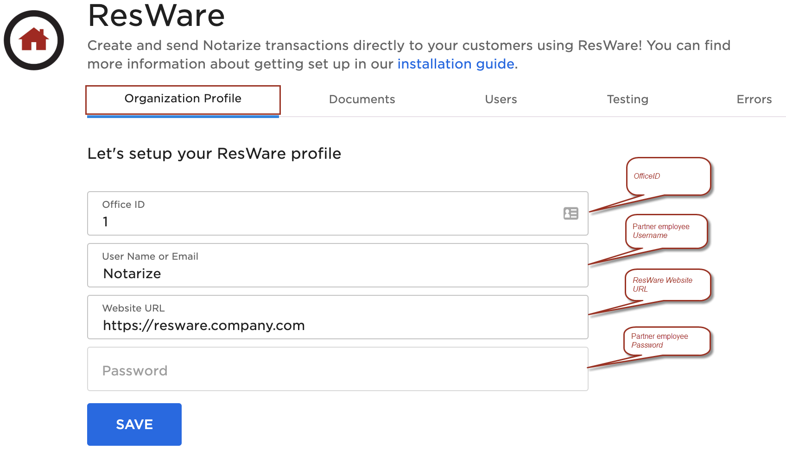

Contact mappings

Resources/Integrations/Contact Mappings
Enter the ResWare partner types that will receive email notifications about the transaction and have access to video participation.

Click Add A Contact Mapping and select Contact Role.

Enter the PartnerTypeID from the ResWare partner types (Admin/Partner Related/Partner Types).

Click Save.
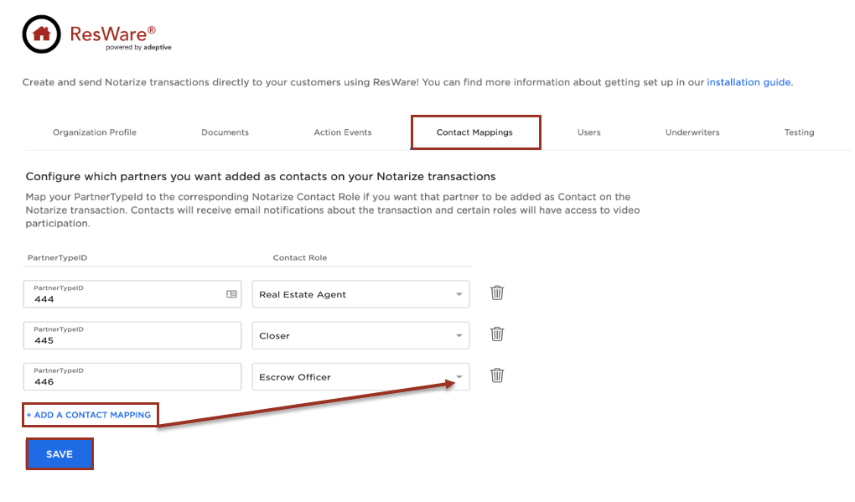

Documents

Resources/Integrations/Documents

Enter the ResWare DocumentTypeIDs for each document package that will be sent to Notarize and that Notarize will send back after they are executed. Respond to the questions on how documents and invoices should be returned, then enter the ResWare DocumentTypeID for the default document type for the Notarized Executed Document created in the prior step.
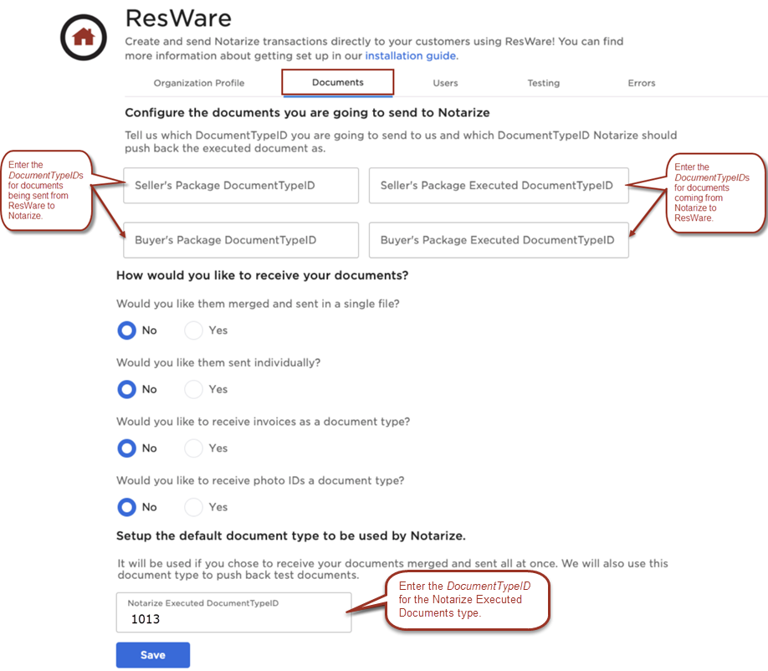

Team

Resources/Team
Add team members in the Notarize portal to match the internal users in ResWare that will use this integration.
- Click Add New Team Member.
- Enter a First Name and Last Name.
- Enter an Email.
- Select a Role.
- Click Add Team Member.
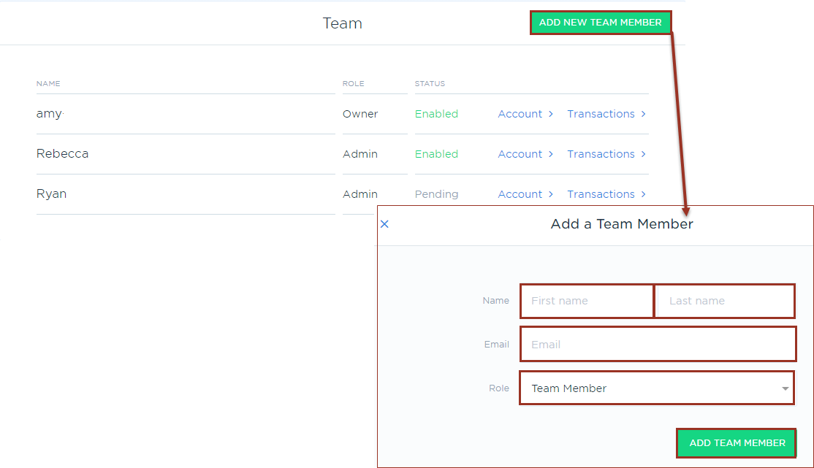

Underwriters

Resources/Integrations/Underwriters
Add the underwriters in the Notarize portal that will be mapped in ResWare and will use this integration.

Click Account and type in an underwriter’s name, then click Add.

Click Save.

Note the UnderwriterID to map in ResWare.
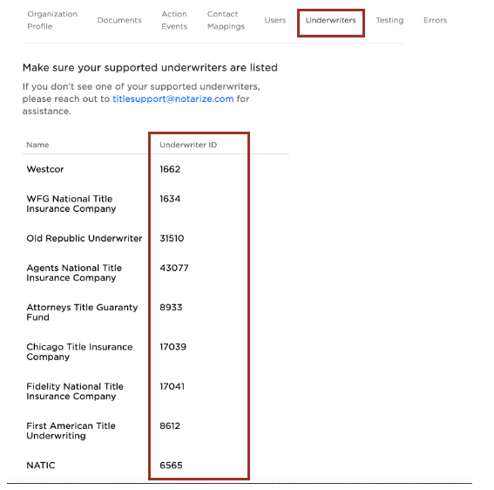

Users

Resources/Integrations/Users
- Note all the Primary Contact IDs to map in ResWare.
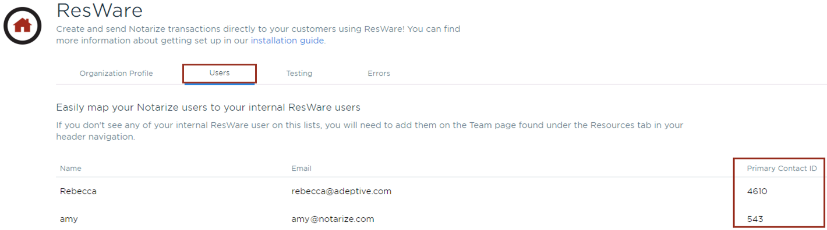

ResWare to ResWare partner mappings

Admin/Partner Related/ResWare to ResWare Partner Mappings
- Click Add, then click Select to search for the partner added in the prior step.
- Enter X as both the Username and Password.

Order placement
  - Verify that the Service Type is set to Order Placement.
  - Enter the URL as https://api.notarize.com/OrderPlacementService/v1/ServiceBasic.svc.
  - Enter the Client ID as 0.
  - Enter the Office ID for the office for which the mapping is being created. Each office will require a separate ResWare to ResWare mapping.
  - Enter the Service Version as v4.
  - Check the box for Don’t Send Sales Price or SSNs.
  - Click Add in the Primary Contact Mapping area to add the team members that were added in the Notarize portal.
    - Select a Contact.
    - Enter the Remote ID as the Primary Contact ID from the Notarize web portal.
    - If only one internal user will be mapped, check Default.
    - Repeat for each user as needed.
    - Click Save.
  - Click Add in the Underwriter Mapping area to add the underwriters that allow eNotarization.
    - Select an Underwriter.
    - Enter the Remote ID as the UnderwriterID from the Notarize web portal.
    - Repeat for each underwriter as needed.
    - Click Save.
  - Click Save.
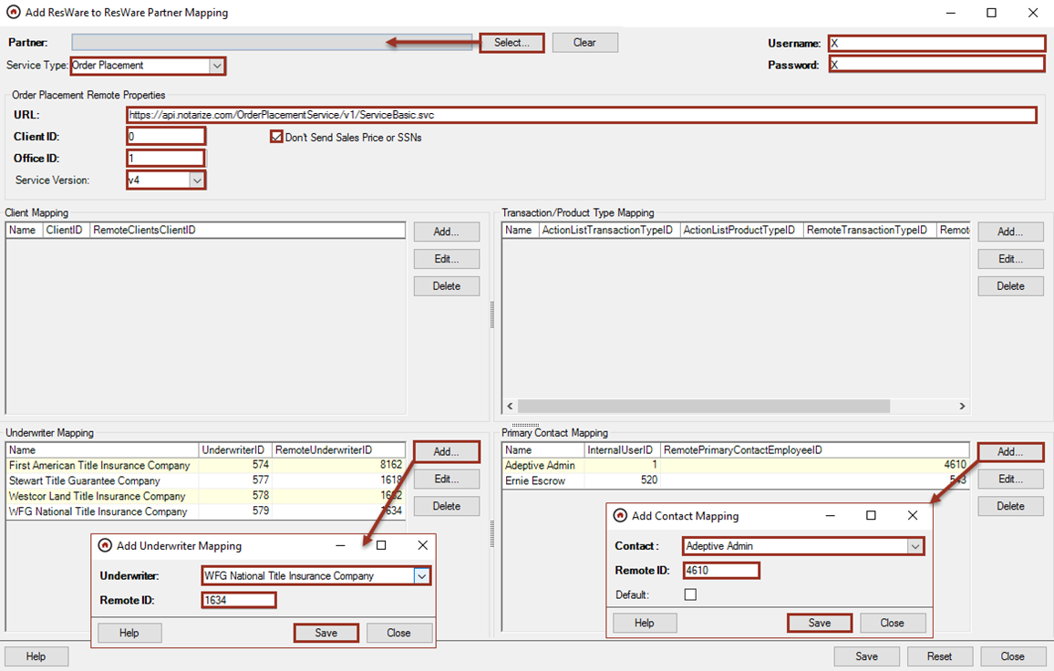

Note/Document
Map the document types in ResWare that will be sent to Notarize.
  - Set the Service Type to Note/Document.
  - Enter the URL as

https://api.notarize.com/ReceiveNoteService/v1/ServiceBasic.svc?om=<RemotePrimaryContactEmployeeID>.

(i.e. If RemotePrimaryContactEmployeeID = 1, then https://api.notarize.com/ReceiveNoteService/v1/ServiceBasic.svc?om=1).

Enter the OfficeID from the first step above as the Coordinator Type ID.
  - In the Document Type Mapping area, click Add and select the Document Type.
    - The Remote ID will default with the DocumentTypeID.
    - Click Save.
    - Repeat the above steps for each document type used in this integration.
  - Click Save.
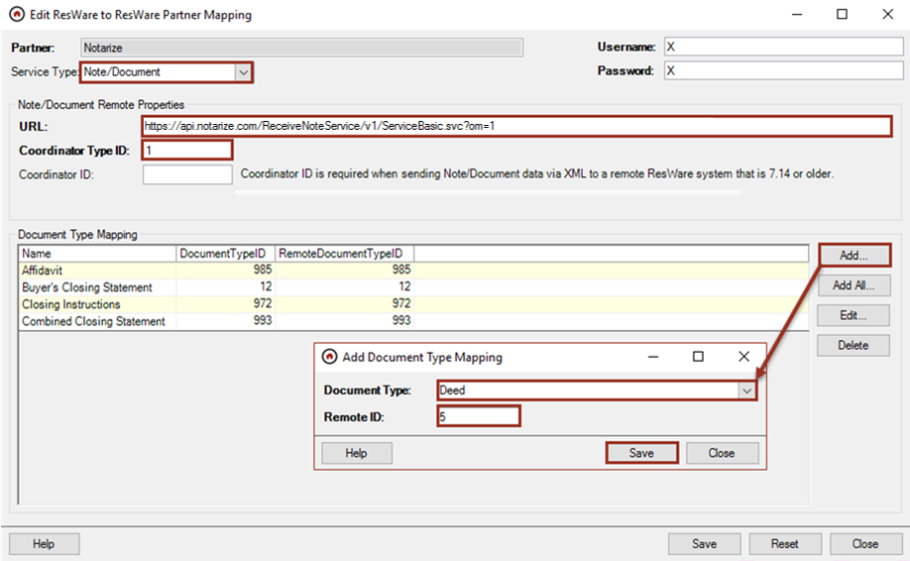

Signings
Signing types in ResWare are transaction types in Notarize. Notarize treats the buyer and seller signings as separate transactions. Signings are based on the parties involved in the signing and can be mapped to more than one transaction type in Notarize. Signing types can also be mapped to a single transaction type in Notarize (e.g. if there are multiple signing types for a seller side purchase, they can all be mapped to RemoteID 3).
  - Set the Service Type to Signing.
  - Enter the URL as

https://api.notarize.com/ReceiveSigningService/v1/ServiceBasic.svc?office_id=[OFFICE_ID]&om=<RemotePrimaryContactEmpoyeeID>.

Replace [OFFICE_ID] with the unique OfficeID from step one of this job aid.

Replace <RemotePrimaryContactEmployeeID> with the primary contact employee’s ID.

In the Signing Type Mapping area, click Add and select the Signing Type. Note: Use only the signing types approved by Notarized and shown in the above step.
    - Enter the Remote ID as shown in the chart:
    - Click Save.
    - Repeat the above steps for each signing type used in this integration.
  - Click Save.
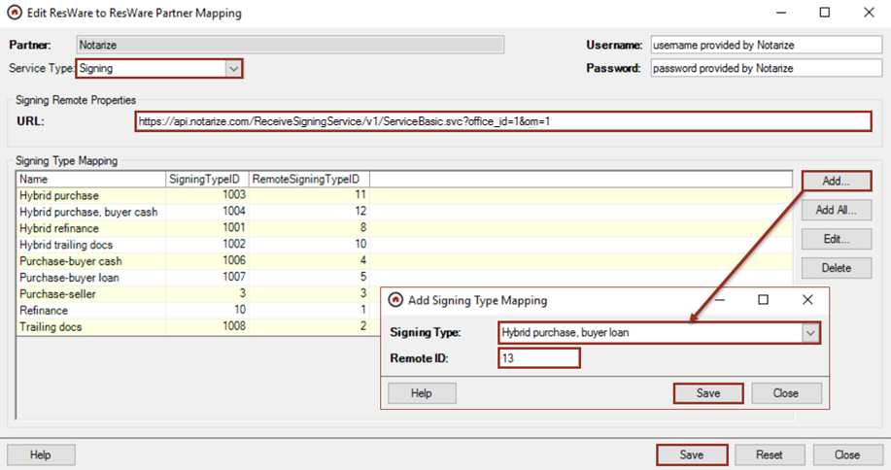

Enable the XML tab on products

Admin/Action Lists/Product Types
- Edit each product that will use the Notarize integration.
- Click the XML tab. If the ResWare XML package already exists on the product, skip to the next product type.
  - Click Add and select ResWare.
  - Click OK.
- Click Save.
- Click Close.
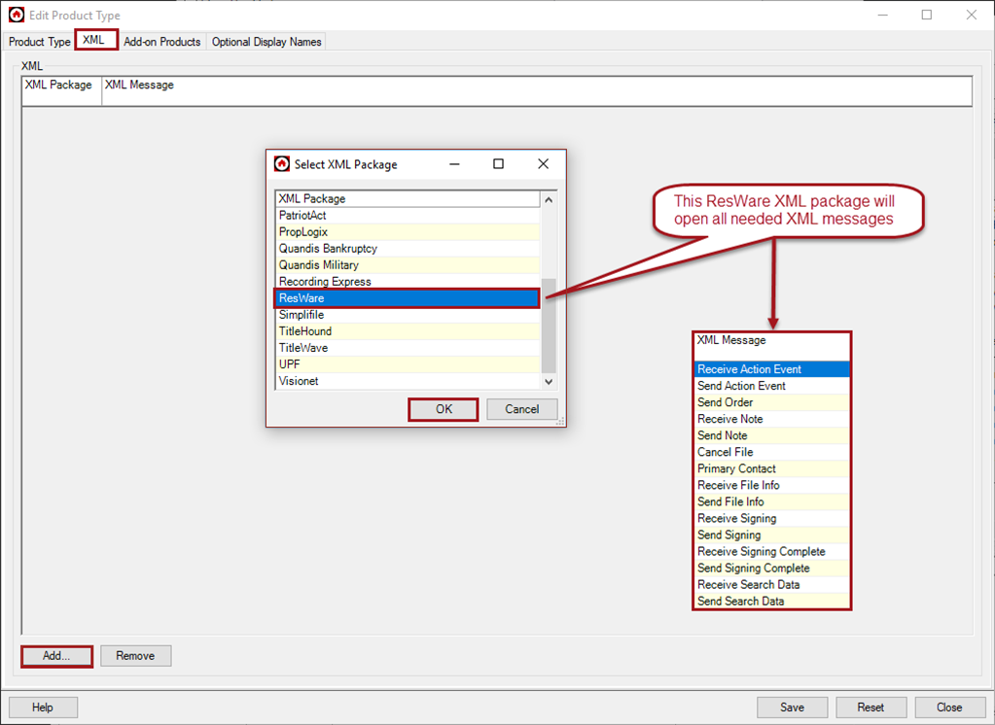

Examples on a file

eClosing eligibility

Notarize will return a note for each file that is submitted through the integration to indicate eligible underwriters and transaction types available based on the property address or will return a message that the file is not eligible for an eClosing.

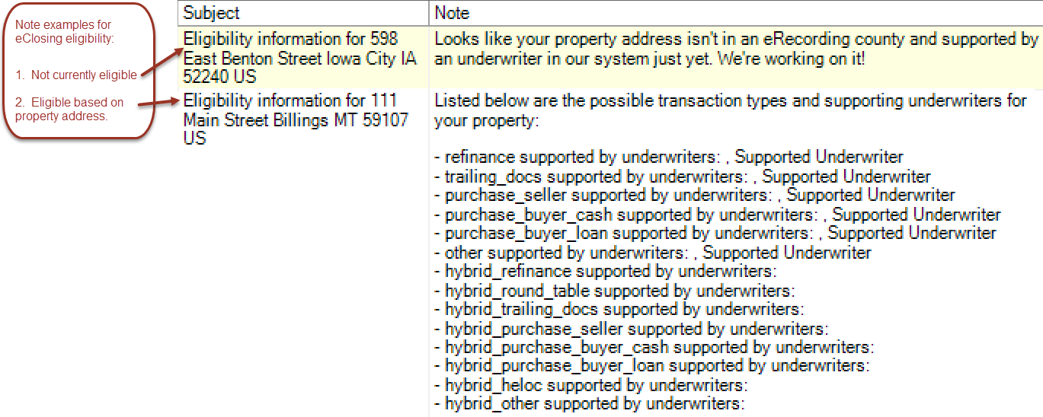

Signings

File/Signings
The Notarize partner must be on the file for this integration to be utilized. The partner can be added manually while creating the signing or by adding the partner on the General panel of the file. The partner could also be auto added by another partner or workflow.
- Click Add to create a signing and enter all pertinent information, including the notary partner.
  - Enter a Date/Time for the signing. This is required for the integration.
  - Select the Type. This is required to notify Notarize which signing type is being requested. Use one of the Notarize approved signing types.
Type | Signer
Hybrid purchase | Seller
Hybrid purchase, buyer cash | Buyer
Hybrid purchase, buyer loan | Buyer
Hybrid refinance | Buyer
Hybrid trailing docs | either
Purchase-buyer cash | Buyer
Purchase-buyer loan | Buyer
Purchase-seller | Seller
Refinance | Buyer
Trailing docs | Either

  - In the Signing Parties area, click Add to select the buyer, seller, or other party who will be the transactee of the signing, then click Save. Note: Verify that the buyer/seller has valid email address.
  - In the Transactee Contact Information area, click Fill from Transactee to populate the information of the transactee, including the email address. If blank, enter an Email Address for the transactee. The email address is required on the buyer or seller panel for this integration.
  - If the Notarize notary partner is already on the file, then, in the Additional Parties area, click the Notary menu to select Notarize.
  - If the Notarize notary partner is not on the file, then click on Add in the Additional Parties area to add the Notarize partner.
  - In the Special Instructions area, enter any additional information or notes to the Notarize team such as notification when a document in the signing package needs special attention or when a transaction requires a split signing.
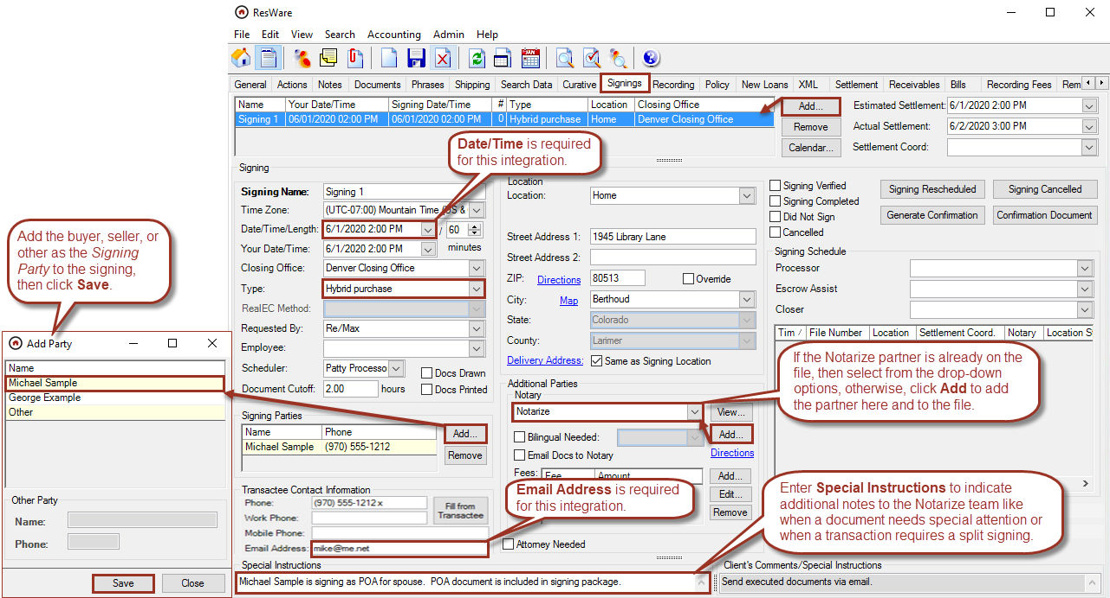

Sending an order

File/XML/ResWare to ResWare
- Select ResWare: Send Order: Notarize from XML Message.
- If multiple contacts are mapped in the above step, then a pop-up will appear so the user can select the contact.
- Click Send.
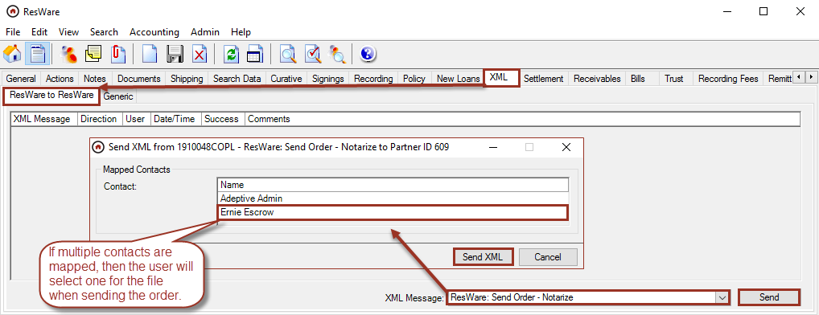
An XML message will be returned showing the order was sent successfully.
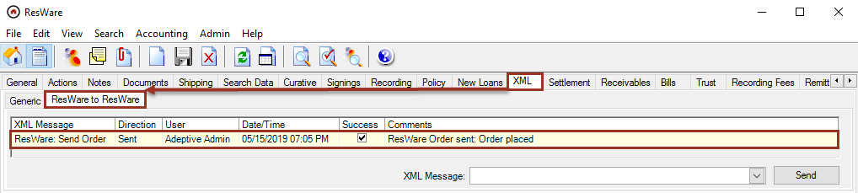
In addition, Notarize will return their assigned transaction number which can be viewed on the File/General panel by selecting the Notarize partner and clicking View. The Notarize transaction number will display in the File Number field. This can be used to track a transaction with Notarize by the transaction number.
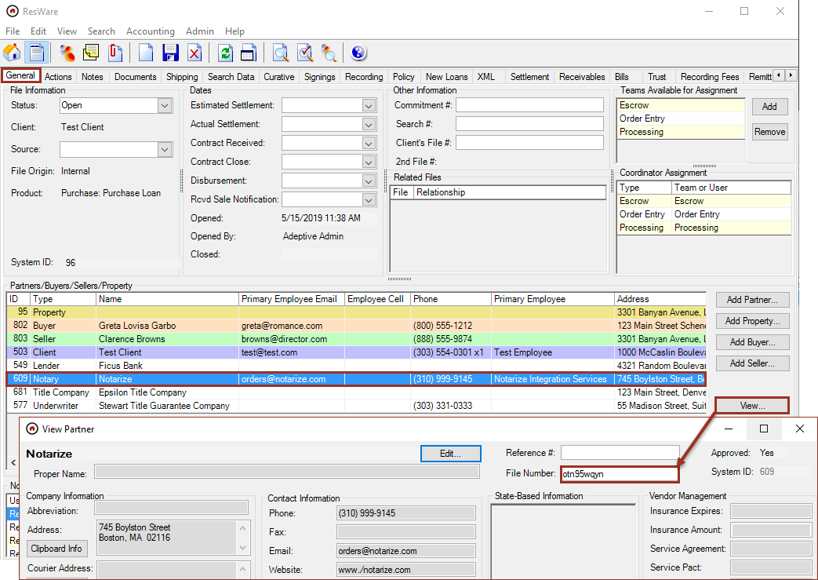

Send signing manually

File/XML/ResWare to ResWare
- Select ResWare: Send Signing: Notarize from XML Message.
- Click Send.
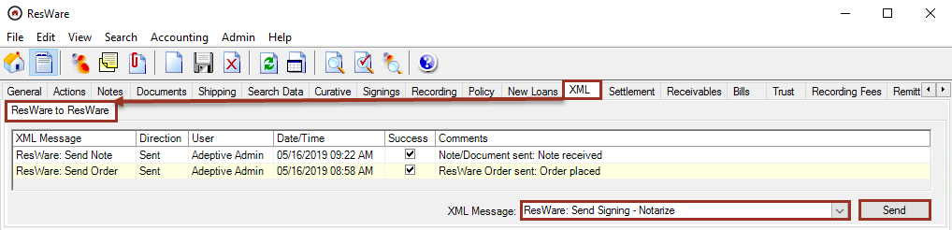
An XML message will be returned showing the order was sent successfully.
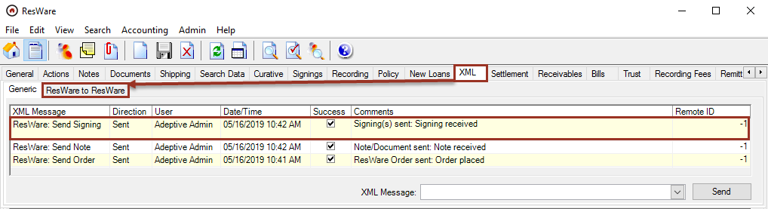

Automate using actions

The following steps will allow a user to incorporate new templates, actions, and affects into the workflow to send orders, signings, and documents to Notarize, further streamlining the process of this integration. The following is an example and can be customized to fit the company’s specific needs. Note: For more information on setting up actions, see the Actions job aid on the customer portal.

Sending documents

Admin/Action Lists/Email Templates
- Click Add.
- Enter the Template Name as XML: Documents to Notarize.
- Select the Send Action:
  - If the sender should be allowed to select options when sending the email, then select Don’t Ask, but display send panel.
  - If the email should be sent automatically with no user intervention, select Automatically send (no user interaction).
- Enter an Email Subject such as XML: Documents to Notarize.
- Select Attach by Document Type in the Attachments area and click Select Doc Types.
  - Select the all of the document types that could be sent with this email template that have been mapped in the previous step above.
  - Click Save.
- Click Select next to Send To: to select which partner type will receive the email.
  - Select the Notary partner type.
  - Click Save.
- In the Partner Specific area, the default is set to All. The email template will be used regardless of the partners present on the file. Optionally, choose Selected and click Add to add the Notarize partner; then the email template will only be used when Notarize is present on the file.
- Click Save.

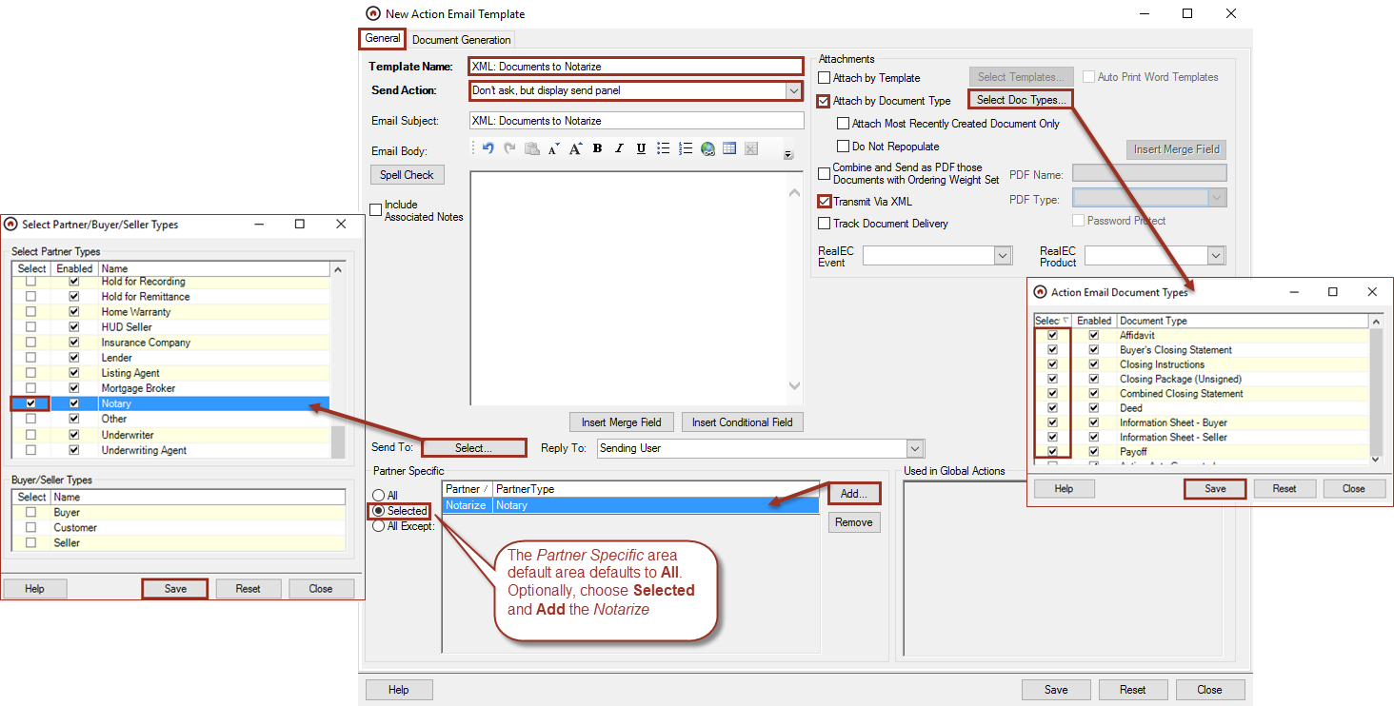

Admin/Action Lists/Action Groups

Create or highlight an action group that will contain the following three actions:

Send the order
- Click Add Action.
- Click New Global Action.
  - Enter the Action Name as Send order to Notarize.
  - Click Save.

Select a Coordinator for the start and complete of the action.

Other options, such as Auto-start when Added to File, may be utilized, depending on what is needed to make the flow of the action group work for each customer.

Click Save.
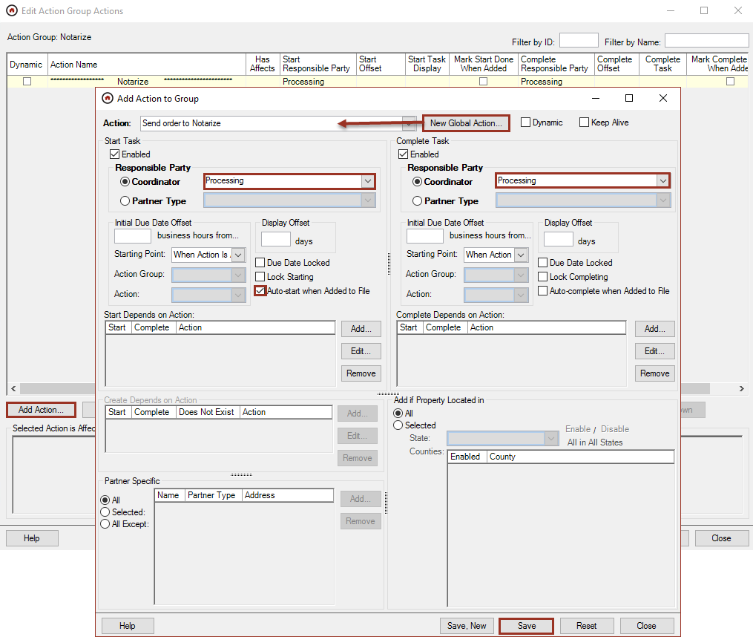
- Highlight the action that was just added and click Edit Affects.
- Click Add the Complete Task Marked Done Affects section.
  - In 5 – Marking Done Sends XML, select the following:
  - XML: ResWare: Send Order
  - Send To: Notary
  - Click Save.
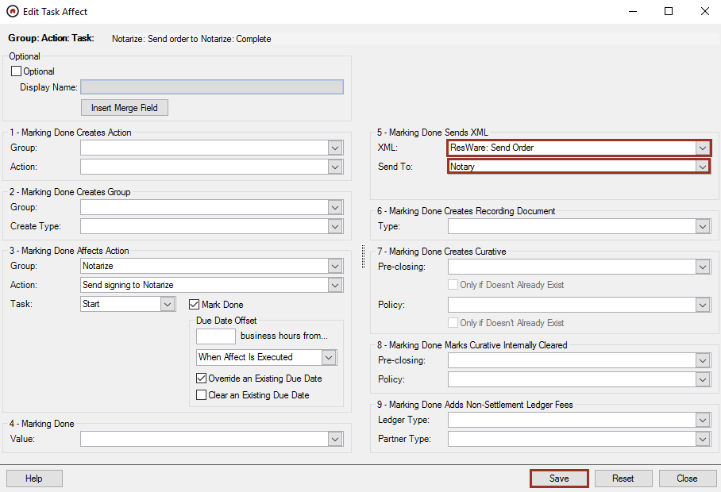

Admin/Action Lists/Global Action

Send the documents
- Click Add.
  - Enter the Action Name as Documents to Notarize.
  - Click Add in the Completing Email Templates area and select the XML: Documents to Notarize template that was created in the step above .
  - Click Save.
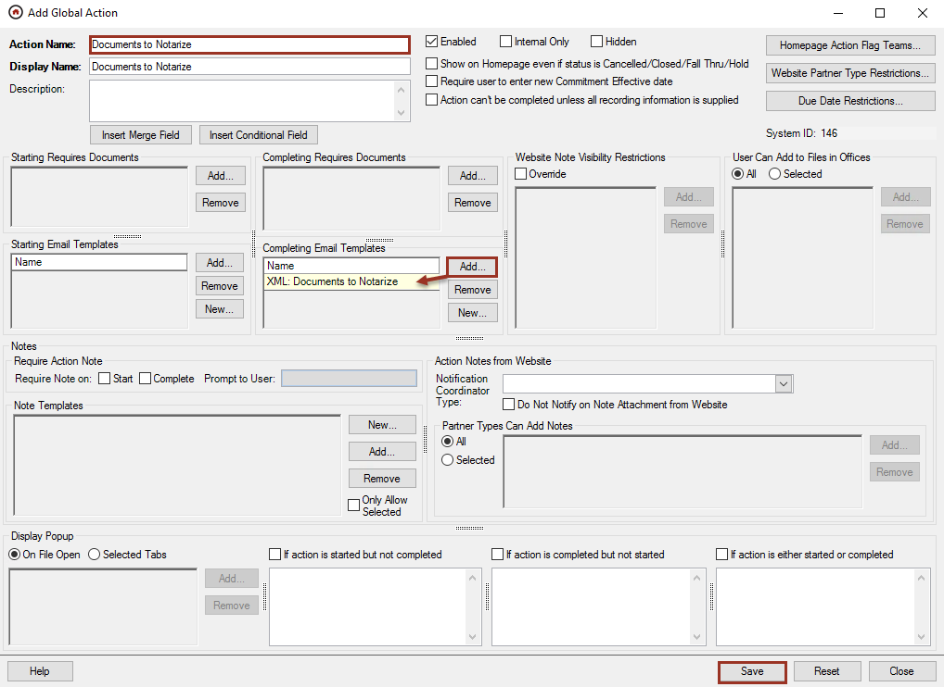

Admin/Action Lists/Action Groups
- Click Add Action.
  - Select the Action Name for Documents to Notarize.
  - Select a Coordinator for the start and complete of the action.
  - Other options, such as Auto-start when Added to File, may be utilized, depending on what is needed to make the flow of the action group work for each customer.
  - Click Save.
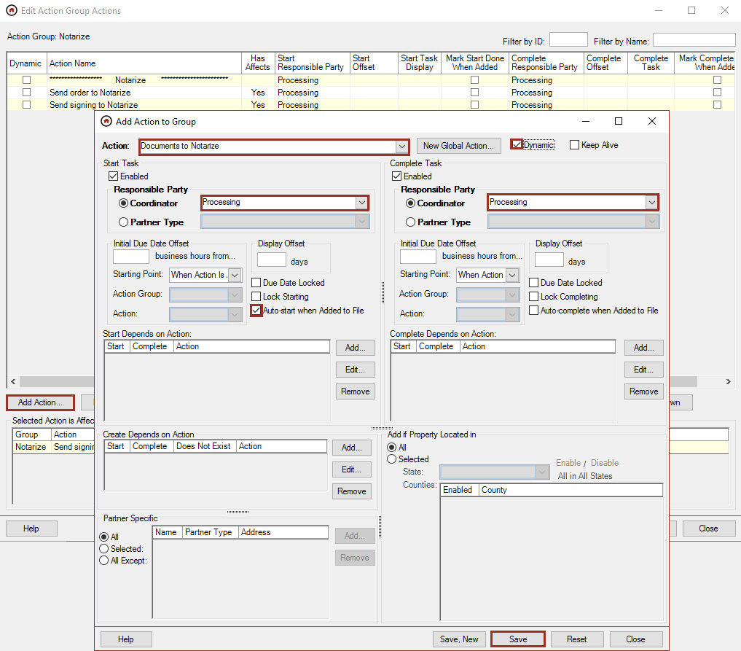

Send the signing
- Click Add Action.
- Click New Global Action.
  - Enter the Action Name as Send signing to Notarize.
  - Click Save.

Select a Coordinator for the start and complete of the action.

Other options, such as Auto-start when Added to File, may be utilized, depending on what is needed to make the flow of the action group work for each customer.

Click Save.
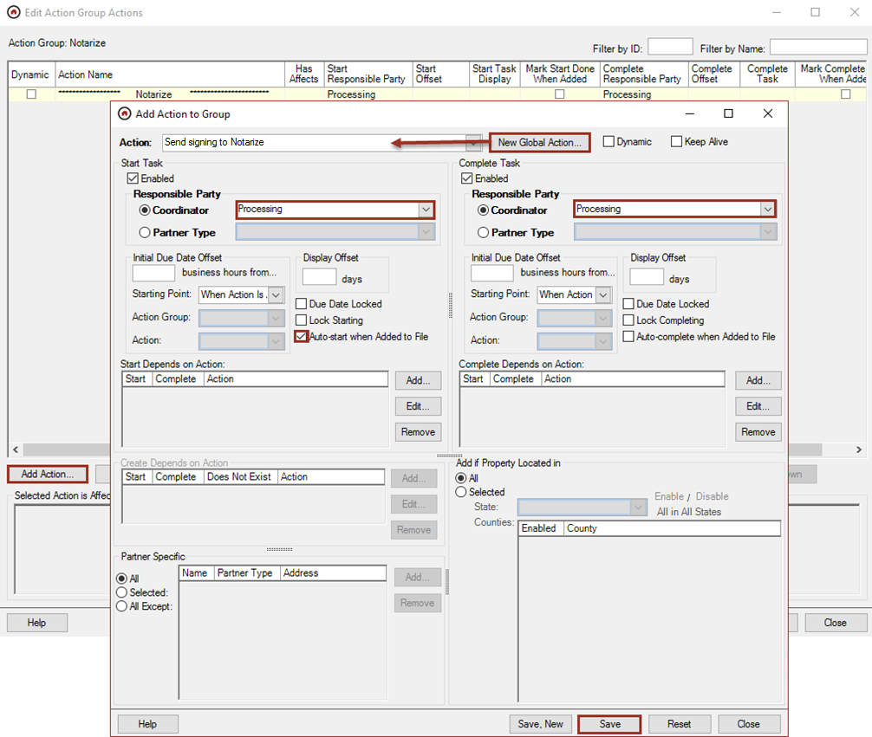
- Highlight the action that was just added and click Edit Affects.
- Click Add in the Complete Task Marked Done Affects section.
  - In 5 – Marking Done Sends XML, select the following:
  - XML: ResWare: Send Signing.
  - Send To: Notary
  - Click Save.
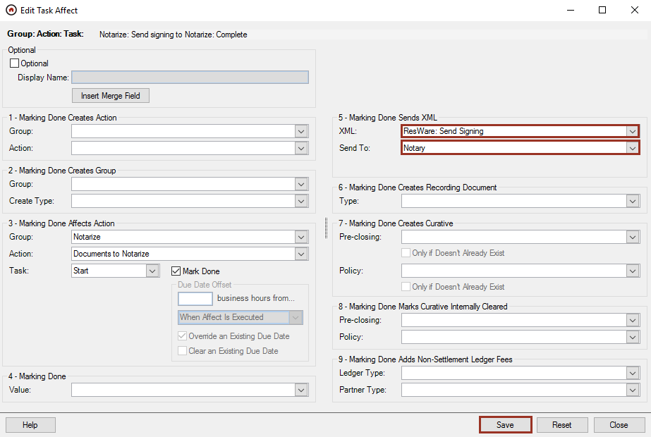
Note: For further information on actions and workflow setup including how to use custom fields to support entity names, see the additional job aids available on the customer portal.

Workflow process
The order of process to complete a transaction with Notarize must begin with Send the order. Send the documents or Send the signing may be done in next in either order.
Send the order – This notifies Notarize that an order will be coming. The user completes the action and there is no interaction.
Send the documents – This provides the documents to the order. The user can manage documents being sent. See information below.
Send the signing – This links the signing to the documents. The user completes the action and there is no user interaction.

File/Actions

In this example, the email template is set to allow the sender to select options when sending the email, including, but not limited to, the ability to edit the Subject, Note, and Attachments. The template will already have pre-selected the document types that are typically sent to the notary; additional documents can be added prior to sending.
- Select the action created in the above steps and click Mark Completed.
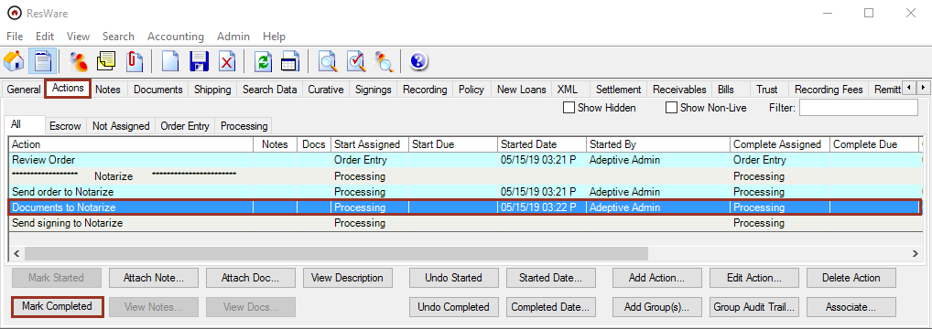
- Click Save after making any needed changes or additions.

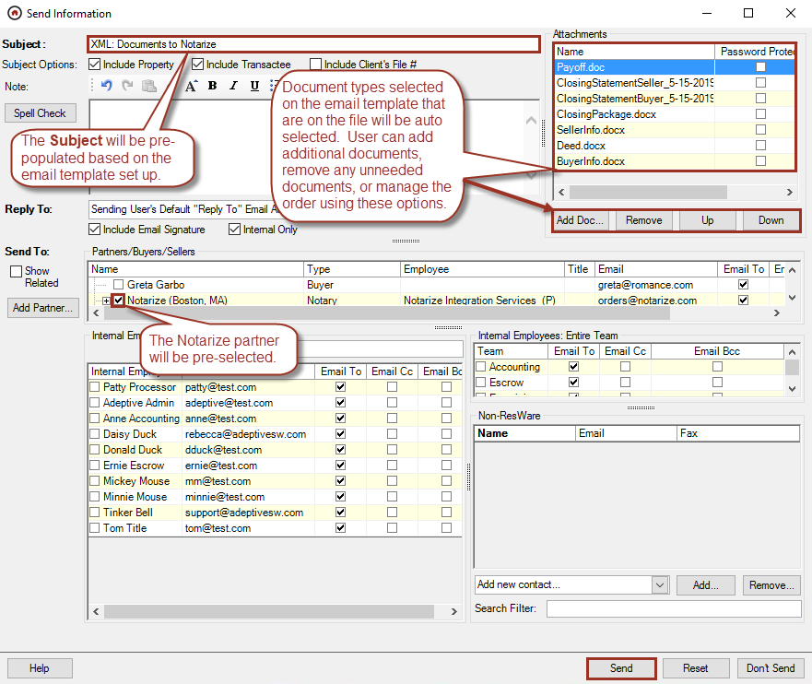
Note: The user can send additional documents manually from the File/Documents panel if needed.
The email sent can be viewed on the File/Notes panel. If a user double-clicks on the number of Docs shown on the note, the File/Documents panel will highlight the documents that were sent in the email.
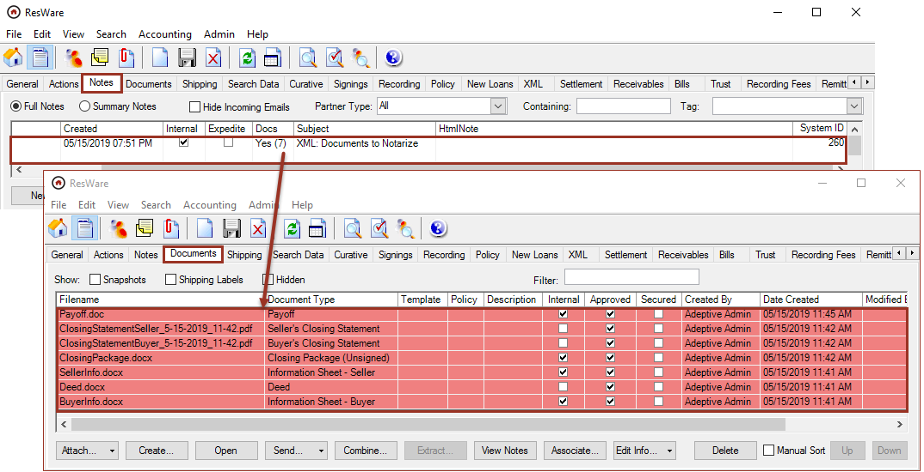

Receive notarized documents

File/Documents
Completed documents will be returned by Notarize and will be available on the File/Documents panel in either a combined package, individual documents, or both. The documents will attach based on the preferences indicated during the integration setup on the Notarize portal. Note: It is recommended that the Document Added action trigger be set to notify someone when these documents have arrived. For more information on setting up triggers, see the Actions job aid on the customer portal.
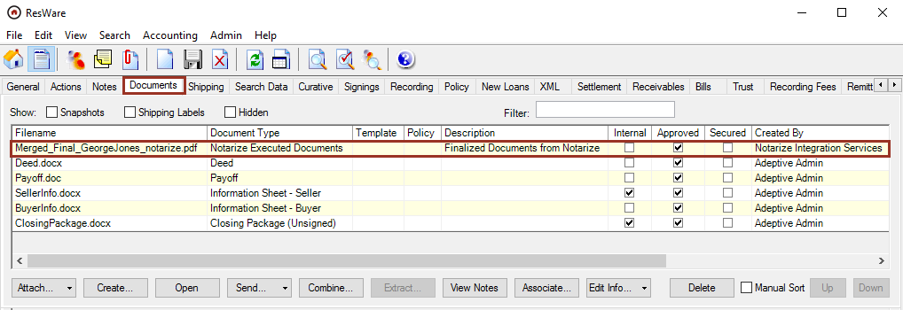
A message will be added on the File/XML panel and a note will also be added to the File/Notes panel.
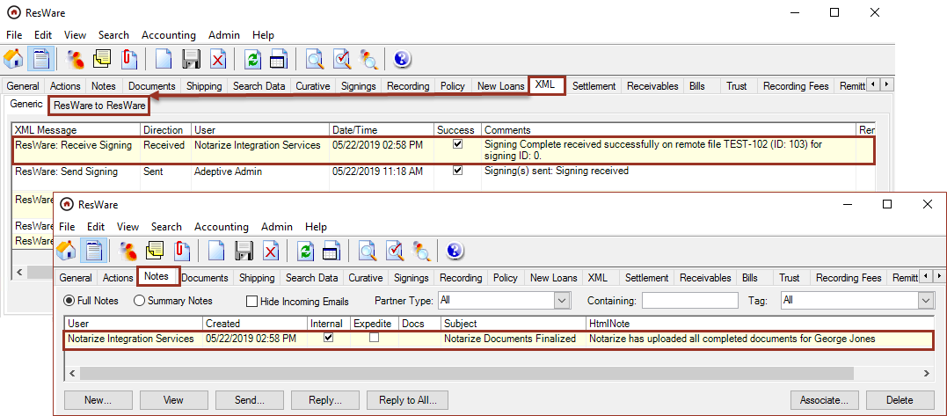

Signing updates

After the initial Send the Order, Send the Signing, and Send the Documents steps have been completed, updated information may need to be sent to Notarize. Updates may be sent to Notarize if the transaction is still being prepared by their closing operations team and has not yet been sent to the signer. If the transaction has already been sent to the signer by the time these updates are received, a message will be returned to contact them directly at orders@notarize.com. The following are guidelines for sending updates through ResWare:

If the update is pertaining to a change on the General or Custom Fields panels (e.g. buyer or seller name):

Edit the necessary field(s) on those panels, then:

File/XML/ResWare to ResWare
- Select ResWare: Send Order: Notarize from the XML Message.
- If multiple contacts are mapped in the above step, then a pop-up will appear so the user can select the contact.
- Click Send.

An XML message will be returned showing the order was sent successfully.

If the update is pertaining to a change on the Signings panel (e.g. closing date/time):

Edit the necessary field(s) on the Signings panel, then:

File/XML/ResWare to ResWare
- Select ResWare: Send Signing: Notarize from XML Message.
- Click Send.
An XML message will be returned showing the order was sent successfully.

If the update is related to a document (e.g. a new document or an updated version of a document already sent), send only the new or updated document rather than the whole package.

File/Documents

Select the document(s) to send to Notarize.

Click Send.

Enter a Subject.

In the Send To area, click the checkbox for the Notarize partner.

Click Send.
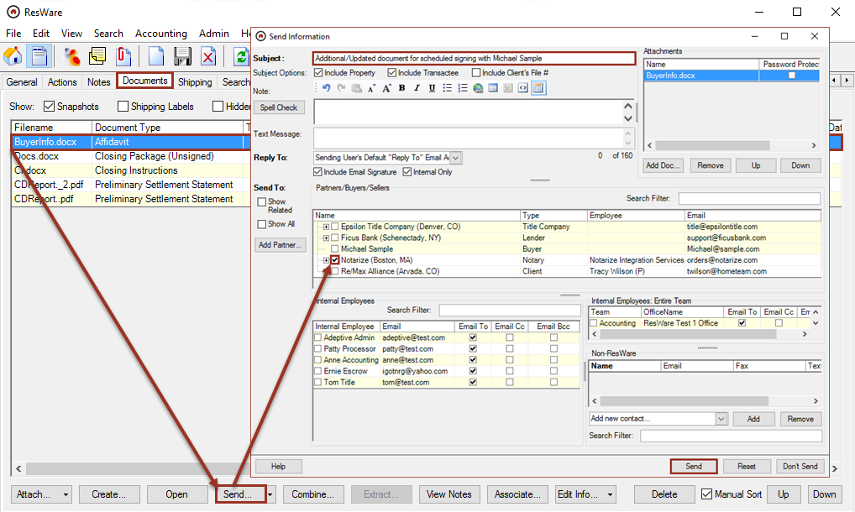
Note: The documents will be sent to Notarize via XML. Confirmation the documents were sent successfully will display on the Notes and XML panels.

Signing cancellation
A signing sent to Notarize can be cancelled before the signer enters the Notarize meeting.

File/Signings

Check the Cancelled box.
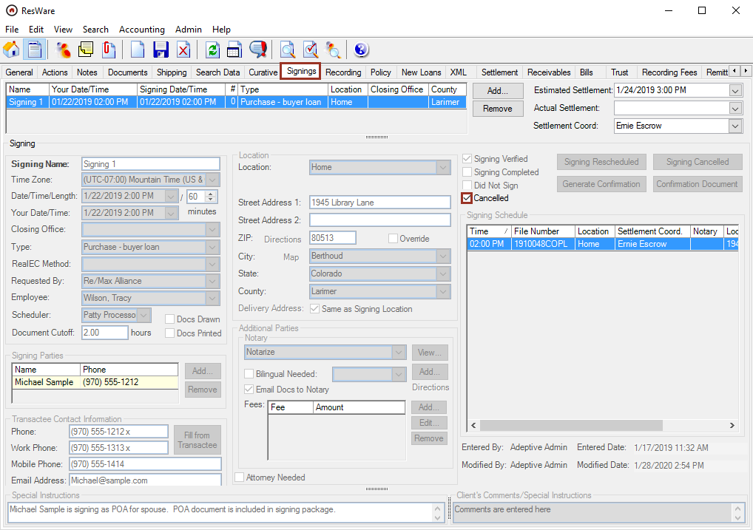

File/XML/ResWare to ResWare
- Select ResWare: Send Signing: Notarize from XML Message.
- Click Send.
An XML message will be returned showing the order was sent successfully.
Note: Once a signing has been cancelled, it cannot be re-sent to Notarize.

Text placeholders
Contact Notarize to enable the white-text auto-tagging feature. The use of text as placeholders in PDF documents allows the designation of signatures, initials, text, and dates to be added in the Notarize platform using their preferred syntax. The syntax is contained within square brackets [] or curly brackets {}, separated with a bar, first with type, then requirement, and then followed by user.
Text tagging values may be standard (white text) or non-standard (black or another non-white font). Contact apisupport@notarize.com to enable non-standard text tagging values, if needed.
Text placeholder information is hosted and maintained at https://dev.notarize.com/docs/white-text-tags.
Text placeholders will behave like pause fields in ResWare in versions earlier than 9.9.34. A user may need to click F11 to continue to next placeholder in the document.
This is a list of the available types of syntax that can be used to designate places on a document that need to be completed and who should complete the field.
For display purposes in this job aid, white text area examples will be shown in red. When creating documents, use white font in places where red is shown.

Types
types | designations |  | types | Notary only designations
check | Checkmark |  | expiry | Expiry
date | Date |  | county | County
initial | Initials |  | id | Id
sig | Signature |  | name | Name
text | Text (open response) |  | seal | Seal
 |  |  | state | State

Req
required | designation
noreq | Optional: not currently supported by Notarize - coming in the future
req | Required

Users
user | designation
notary | Assigned to notary
signerX | Assigned to signer, where X is a number assigned to a specific signer
witnessX | Assigned to a witness, where X is a number assigned to a specific witness

Sizing
The size of placeholders can be adjusted by height and width within the space of the square brackets.

To increase the height, increase the font size.
[sig|req|signer1] [sig|req|signer1]

To increase the width, add spaces before the closing square bracket.
[sig|req|signer1] [sig|req|signer1 ]
Note: resizing may not be consistent with Notarize’s defaults:

Signatures and initials will fill to the maximum size of the placeholder.

Checkboxes always default to a 16px by 16px checkbox regardless of placeholder size.

Text and date will always default to a 14px font size and the text can stretch beyond the dimensions of the placeholder.

Defining a variable

Where there is not enough space to include a normal white text placeholder, a variable can be defined in the document, then the variable can be inserted where needed. This is commonly used for checkboxes or initials.

Define the variable using the following prefix information within the square brackets:

def:$variableName

Examples: [def:$in1|initial|req|signer1] or [def:$chk1|initial|req|signer1]

Use the defined variable:

[$variableName]

Example: [$in1] or [$chk1]

Example
Billy Buyer and Barbara Buyer, buyers, and Sam Seller and Sally Seller, sellers, hereby enter into an agreement for the purchase and sale of the big house with the white fence located at the end of the street for one million dollars.
Please initial key terms below:
[def:$in1|initial|req|signer1] [def:$in2|initial|req|signer2]
_____ [$in1] _____ [$in2] Sellers agree to keep the bushes looking nice prior to sale.
_____ [$in1] _____ [$in2] Buyers agree to take great care of the house.
Please check below to indicate your understanding:
[def:$chk1|check|req|signer1] [def:$chk2|check|req|signer2]

r [$chk1] r [$chk2] Buyers accept the home as-is, where-is.

By signing below, Billy Buyer and Barbara Buyer agree to these comically simple terms.

[sig|req|signer1] [text|req|signer1] [date|req|signer1]
____________________ __________________________ ________________
Billy Buyer Address Date

[sig|req|signer2] [text|req|signer2] [date|req|signer2]
____________________ ________________ ________________
Barbara Buyer Address Date
By signing below, Sam Seller and Sally Seller agree to these comically simple terms.

[sig|req|signer1] [text|req|signer1] [date|req|signer1]
____________________ __________________________ ________________
Sam Seller Address Date

[sig|req|signer2] [text|req|signer2] [date|req|signer2]
____________________ __________________________ ________________
Sally Seller Address Date

State of: [state|req|notary]
County of: [county|req|notary]

[name|req|notary] [text|req|notary ]
Notarial language stating that I ___________________________, witnessed ________________________________________

___________________________________________________________________________________ signing this document.

[expiry|req|notary]
My Commission expires: __________________ [sig|req|notary]
[id|req|notary] _______________________________
Notarial ID# _____________ (Notary Public)

[seal|req|notary ]

ResWare merge fields for text placeholders
The following merge fields in ResWare are used for remote online notarization signings with Notarize. These merge fields contain the Notarize text formatting necessary to add text placeholders into documents created in ResWare. These merge fields are added by request only. Contact support@adeptive.com to have these merge fields added.

BuyerSellerNamesWithSignatureLinesAndSignatureTags
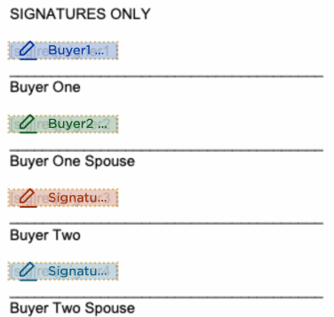

BuyerSellerNamesWithSignatureLinesWithDateAndSignatureTags
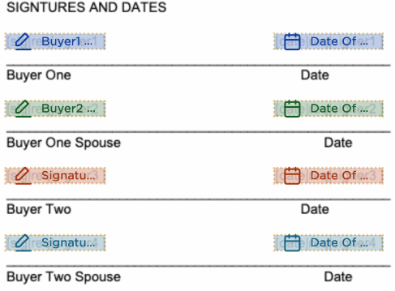

BuyerSellerNamesWithSignatureLinesWithNotaryJuratAndSignatureTags
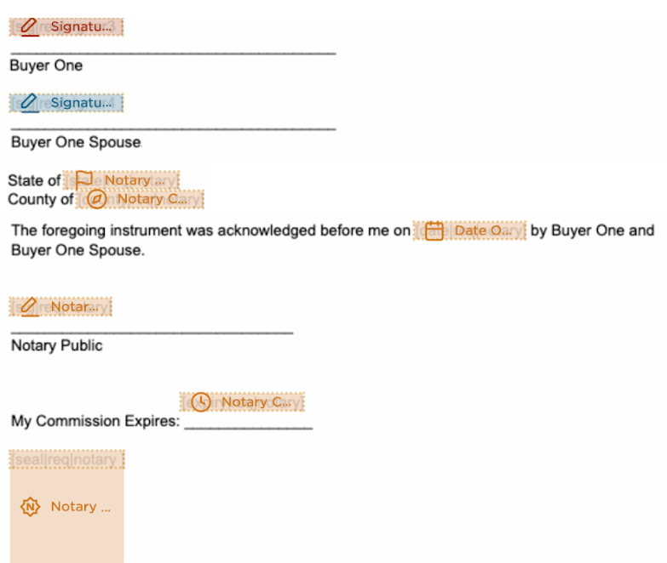

Entity signatories
Entity buyers and sellers of properties represent significant volume for many title agents, whether it is a corporation, trust, or other entity involved in a real estate transaction. Since an entity cannot sign closing documents, there are signatories appointed for each entity that can sign documents on behalf of the entity. Using custom fields in ResWare will allow the integration to support these entity signatory use cases.

Custom fields

Admin/Document and Templates/Custom Fields
Create a set of custom fields for each signor that could possibly be needed on one file where x = a number.
Buyer fields | Seller fields
Entity Buyer Signatory x Email | Entity Seller Signatory x Email
Entity Buyer Signatory x First name | Entity Seller Signatory x First Name
Entity Buyer Signatory x Middle name | Entity Seller Signatory x Middle Name
Entity Buyer Signatory x Last name | Entity Seller Signatory x Last Name
Entity Buyer Signatory x Title | Entity Seller Signatory x Title

Click Add and enter a Name such as Entity Buyer Signatory 1 Email.
Note: Custom field names must match exactly as shown in chart above to work in this integration.

Set the Type as Text.
Note: Do not add Values.

Click Save.

Repeat steps to create custom fields for each set of signatories as needed (e.g., buyers 1-5).
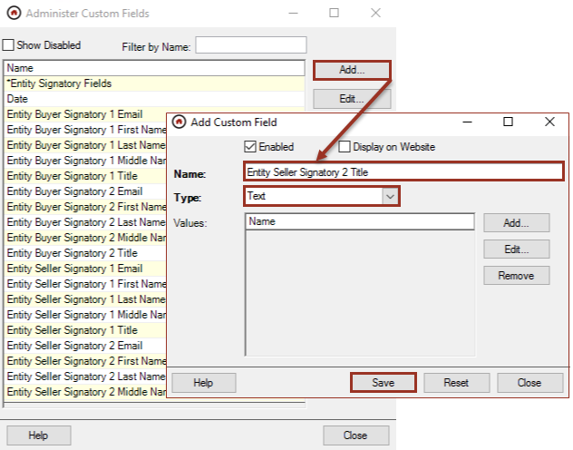

Template
Create a template to add the above custom fields. A file where entity signatories are needed will need to generate a document using this document template. This will add the Custom Fields panel to the file and make the custom fields available to use with the integration.

Admin/Documents and Templates/Templates

Click Add then enter a Template Name such as Entity Signatories.

Click New to create the Filename.

A new panel will open, and the Template Name will default as the File name.

Click Word.

Set the Document Type.

In the Enable for Counties area, set All to allow this document to be used on all files.

In the Contained in Categories area, click Add to include the template in categories as needed. A minimum of one category must be selected to have access to the template.
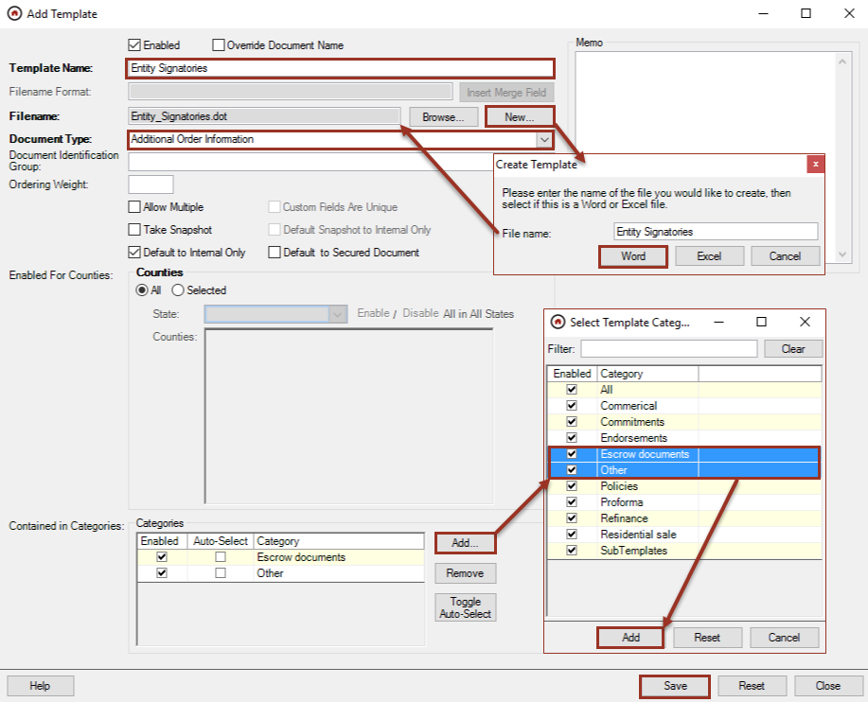

Click Add-Ins, then Insert ResWare Field, and select a custom field added in the prior step, then click Insert.

Repeat until all entity signatory custom fields have been added.

Click Update All Docs & Close or the X to save and close the template.
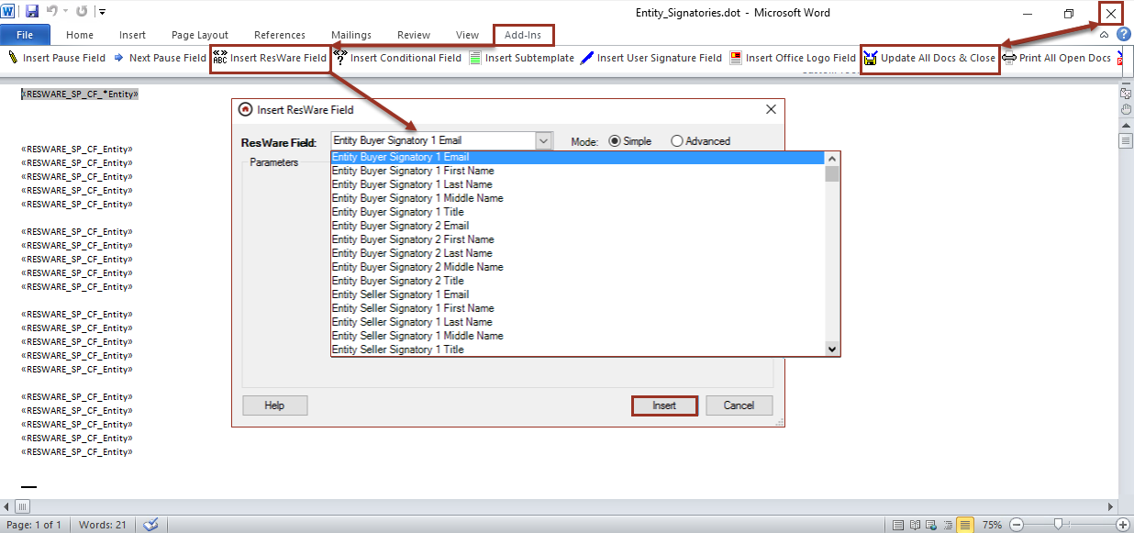

Example on a file

File/Documents
The document can be added manually to a file or auto added through the action workflow. See job aids for further information on auto adding.

Click Create.

Set the Category where the template is located.

Select the template and click Create Selected.

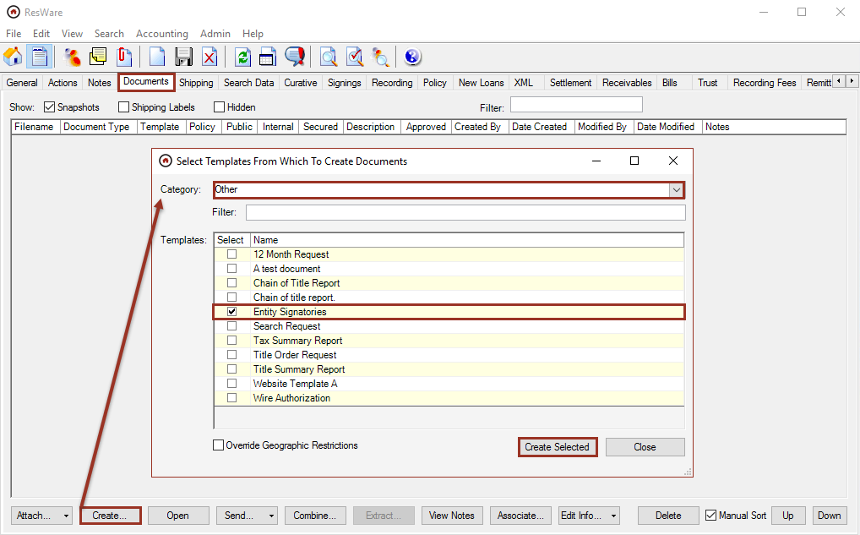
The Custom Fields panel will open allowing a user to complete the necessary information for the file.
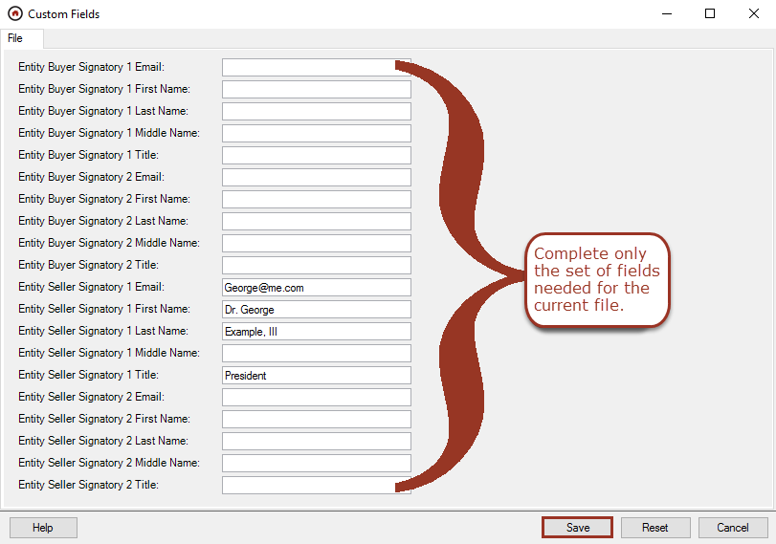
Note: The first name may include a prefix if needed; the last name may include a suffix if needed; and the middle name is optional.

Click Save after the buyer/seller information necessary for the file is entered.

Save the document to the file.
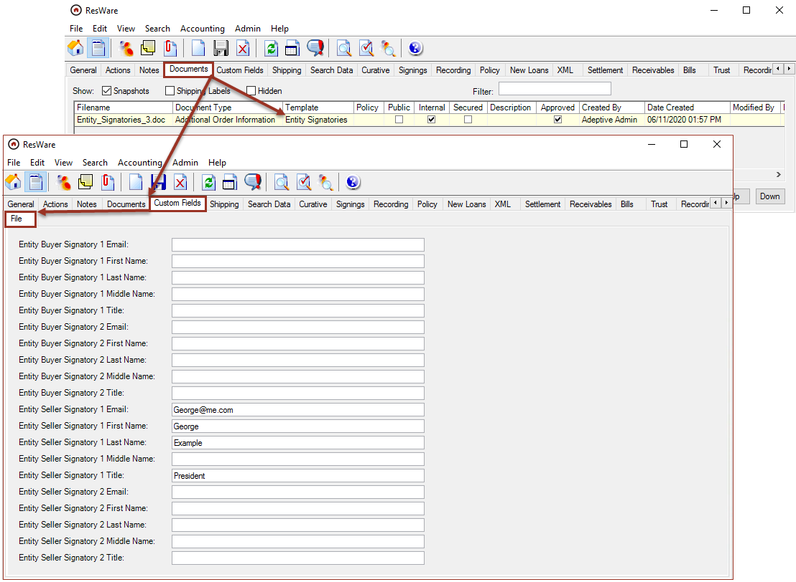
Note: To update a buyer/seller from an entity type to an individual or other entity type, disable the current buyer/seller, add a new buyer/seller with the correct type, then place order again. This will push an update in the corresponding Notarize transaction.

Troubleshooting
If the following error message is received: Could not establish secure channel for SSL/TLS with authority ‘api-internal.notarize.com’

Update the order placement, note/document, and signing URLs with the prefix as https://api-external.notarize.com/ (i.e. https://api.external.notarize.com/OrderPlacementService/v1/ServiceBasic.svc).
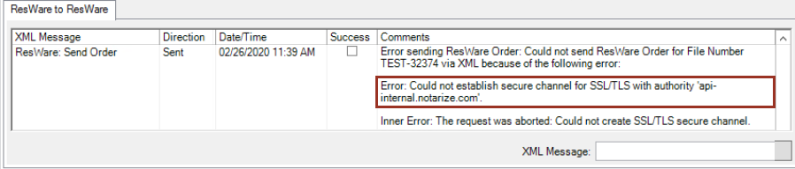
If using the signing type 1-Refinance, the lender on the file must be setup with Notarize and must send the signing request to the title company first. Otherwise, use signing type 8-Hybrid Refinance when the lender is not a client of Notarize.
If the following error message is received: “The signing# (signing number) has no signatories for {Entity Buyer/Seller Name}”

The entity signatory information is required if there is an entity buyer or seller on the file and there are documents in the file that need to be signed by that entity. Verify that the custom fields are added and completed for that entity.
If the following error message is received: “Invalid Buyer/Seller: the {Field name} field is missing for {buyer/seller name}”

This error will show if any one field is filled out for an entity signatory. If one field has data, then the other fields for that signatory are required.

